M07 Chapter 12 Hands On Submission
- Hands-On Project 12-1
  - Use Chapter 12 Trace File: ARP ScanDownload Chapter 12 Trace File: ARP Scan
  - Screenshot showing the expanded packet (step 4)
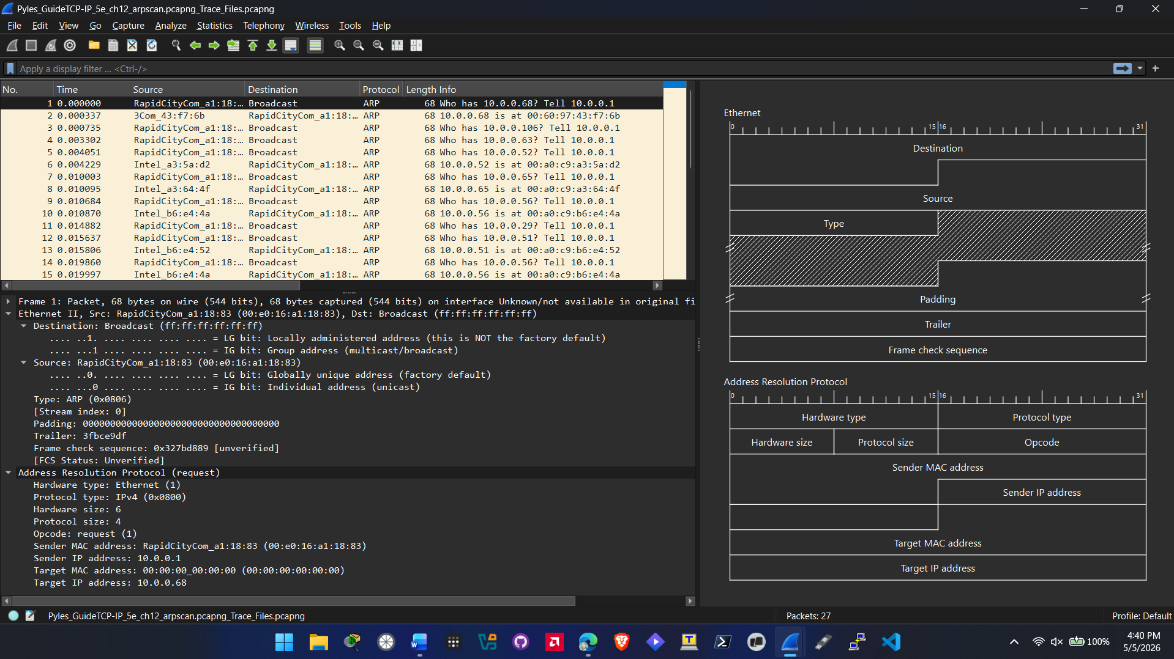
  - Answer questions 4A, 4B, 4C
4A. The IP address of the device is 10.0.0.1
4B. Discovered Hosts: 10.0.0.68, 10.0.0.106, 10.0.0.63, 10.0.0.52, 10.0.0.65, 10.0.0.56, 10.0.0.29, 10.0.0.51, 10.0.0.49, 10.0.0.55,
4C. There are a couple of ways this type of scan can be used on a small routed network. Net admins can use this scan for network mapping or taking inventory of all the devices on the local network. You can Identify unauthorized devices on your network. You can also use this as reconnaissance for auditing or If you were a threat actor it can be used similarly but so you can know the devices on a network.
- Hands-On Project 12-2
  - Use Chapter 12 Trace File: Port ScanDownload Chapter 12 Trace File: Port Scan
  - Answer questions 3, 4, 5A, 5B, 5C
3. Flag set in packet 1: SYN 0x002
4. Flags set in packet 2: RST, ACK 0x014
5A. The port scan is obvious. If you look at every packet in the capture its SYN scanning multiple ports in a row starting at port 1. It also originates from one IP and hitting multiple ports.
5B. No, it will not since DHCP operates over UDP and not TCP. The capture only shows the scanner using TCP SYN packets.
5C. The ports that are active on the destination device are port 2306 and port 2310.
- Hands-On Project 12-3
  - Use Chapter 12 Trace File: Port ScanDownload Chapter 12 Trace File: Port Scan
  - Screenshot showing filtered packets (step 9)
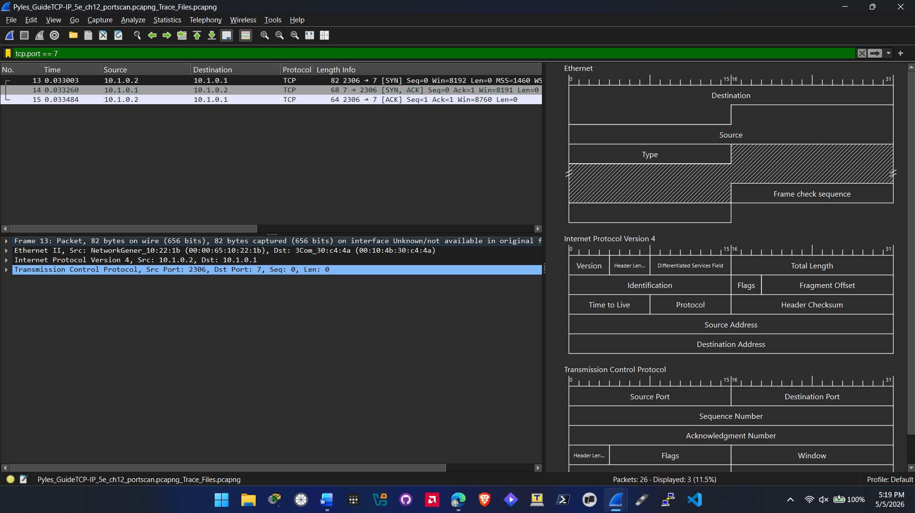
  - Answer the two questions in step 9.
Step 9. Yes the filter worked, Yes I see the packets packet 13 and 15s destination port is 7 and packet 14 source port is port 7.
- Hands-On Project 12-4
  - Use Chapter 12 Trace File: Port ScanDownload Chapter 12 Trace File: Port Scan
  - Screenshot showing the capture filter you created (step 4)
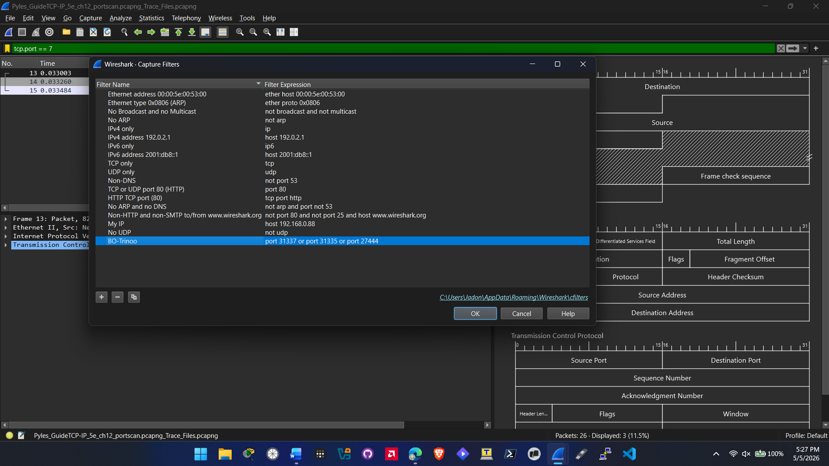
- Hands-On Project 12-5
  - Use Chapter 12 Trace File: OSScanDownload Chapter 12 Trace File: OSScan
  - Answer questions 3, 5A, 5B, 5C, 5D
3. Top Talkers: 10.1.0.102, 10.1.0.103, 10.1.0.200
5A. For packet 1671 and 1672: the resolved host name is win7_03_ipv6sandbox.com
5B. the probable ipv4 of the attacker is 10.1.0.103 which is the address that initiates the standard query .
5C. The probable IPv4 address of the attacked is 10.1.0.200. the first packet is looking for 200.0.1.10.in-addr.arpa which is the reverse pointer for the address.
5D. the correlation is that those 2 address were the #2 and #3 top talker in the capture.
- Hands-On Project 12-6
  - Use Chapter 12 Trace File: OSScanDownload Chapter 12 Trace File: OSScan
  - Answer questions 3, 5A, 5B, 5C, 5D
3. Top Talkers are:
2001:db8:1ab:ba5e::109
2001:db8:1ab:ba5e::114
2001:db8:1ab:ba5e::2000
5A. the host name involved in this attack for packet 4389 and 4390 is win7_03.ipv6sandbox.com
5B. the probably attacker is 2001:db8:1ab:ba5e::114. In packet 4389 it initiated a query for the IPv6 PTR record.
5C. the probable IPv6 address of the attacked is 2001:db8:1ab:ba5e::109. Its because the query is for 9.0.1.0.0.0.0.0.0.0.0.0.0.0.0.0.e.5.a.b.b.a.1.0.8.b.d.0.1.0.0.2.ip6.arpa and when read in reverse it corresponds to that address.
5D. ::109 and ::114 are the top two talkers in the IPv6 statistics.

